import pandas as pd
# Load your dataset
data = pd.read_csv('dataset.csv')
# Data cleaning and preprocessing steps (e.g., handling missing values, data type conversions, etc.)
# Example: Convert 'WeekBeginning' column to datetime
data['WeekBeginning'] = pd.to_datetime(data['WeekBeginning'], format='%d-%m-%Y %H:%M')
# More data cleaning and preprocessing steps can be added here
data.head(25)
TripID RouteID StopID StopName WeekBeginning \
0 23631 100 14156 181 Cross Rd 2013-06-30
1 23631 100 14144 177 Cross Rd 2013-06-30
2 23632 100 14132 175 Cross Rd 2013-06-30
3 23633 100 12266 Zone A Arndale Interchange 2013-06-30
4 23633 100 14147 178 Cross Rd 2013-06-30
5 23634 100 13907 9A Marion Rd 2013-06-30
6 23634 100 14132 175 Cross Rd 2013-06-30
7 23634 100 13335 9A Holbrooks Rd 2013-06-30
8 23634 100 13875 9 Marion Rd 2013-06-30
9 23634 100 13045 206 Holbrooks Rd 2013-06-30
10 23635 100 13335 9A Holbrooks Rd 2013-06-30
11 23635 100 13383 8A Marion Rd 2013-06-30
12 23635 100 13586 8D Marion Rd 2013-06-30
13 23635 100 12726 23 Findon Rd 2013-06-30
14 23635 100 13813 8K Marion Rd 2013-06-30
15 23635 100 14062 20 Cross Rd 2013-06-30
16 23636 100 12780 22A Crittenden Rd 2013-06-30
17 23636 100 13383 8A Marion Rd 2013-06-30
18 23636 100 14154 180 Cross Rd 2013-06-30
19 23636 100 13524 8C Marion Rd 2013-06-30
20 23636 100 14122 173 Cross Rd 2013-06-30
21 23636 100 13813 8K Marion Rd 2013-06-30
22 23637 100 14156 181 Cross Rd 2013-06-30
23 23637 100 14154 180 Cross Rd 2013-06-30
24 23637 100 13335 9A Holbrooks Rd 2013-06-30
NumberOfBoardings
0 1
1 1
2 1
3 2
4 1
5 1
6 1
7 1
8 1
9 1
10 1
11 1
12 2
13 1
14 1
15 1
16 1
17 1
18 2
19 3
20 1
21 1
22 1
23 1
24 3

# Convert WeekBeginning to datetime and extract week number
data['WeekBeginning'] = pd.to_datetime(data['WeekBeginning'])
data['WeekNumber'] = data['WeekBeginning'].dt.week
# Group data by WeekNumber and sum the NumberOfBoardings
weekly_boardings = data.groupby('WeekNumber')['NumberOfBoardings'].sum()
# Plotting
plt.figure(figsize=(10, 6))
plt.plot(weekly_boardings.index, weekly_boardings.values, marker='o', color='green')
plt.title('Weekly Boarding Trends')
plt.xlabel('Week Number')
plt.ylabel('Total Number of Boardings')
plt.grid(True)
plt.tight_layout()
plt.show()
<Figure size 1000x600 with 0 Axes>
[<matplotlib.lines.Line2D at 0x7ccb71cf2bf0>]
Text(0.5, 1.0, 'Weekly Boarding Trends')
Text(0.5, 0, 'Week Number')
Text(0, 0.5, 'Total Number of Boardings')
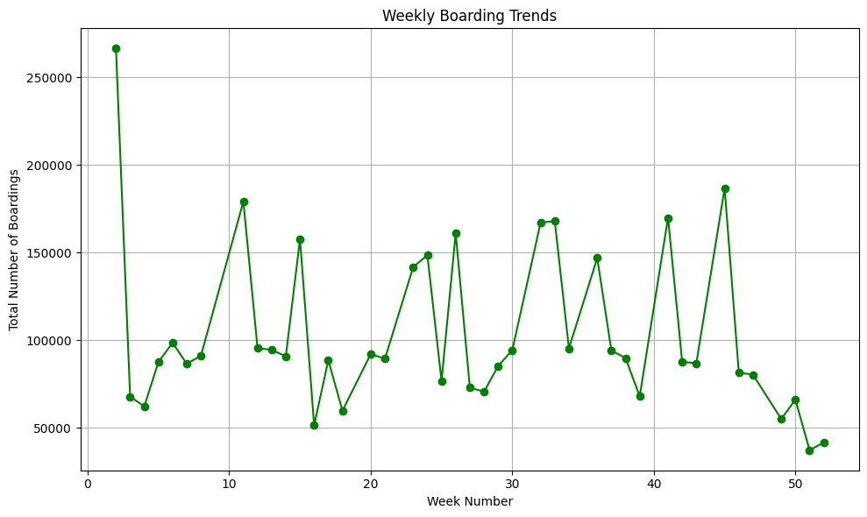
import matplotlib.pyplot as plt
# Group data by StopName and sum the NumberOfBoardings
boarding_counts = data.groupby('StopName')['NumberOfBoardings'].sum()
# Plotting
plt.figure(figsize=(12, 6))
boarding_counts.sort_values(ascending=False).head(10).plot(kind='bar', color='skyblue')
plt.title('Top 10 Stops by Total Number of Boardings')
plt.xlabel('Stop Name')
plt.ylabel('Number of Boardings')
plt.xticks(rotation=45, ha='right')
plt.tight_layout()
plt.show()
<Figure size 1200x600 with 0 Axes>
<Axes: xlabel='StopName'>
Text(0.5, 1.0, 'Top 10 Stops by Total Number of Boardings')
Text(0.5, 0, 'Stop Name')
Text(0, 0.5, 'Number of Boardings')
(array([0, 1, 2, 3, 4, 5, 6, 7, 8, 9]),
[Text(0, 0, 'W1 North Tce'),
Text(1, 0, 'I1 North Tce'),
Text(2, 0, 'V2 Currie St'),
Text(3, 0, 'E2 Currie St'),
Text(4, 0, 'V1 Currie St'),
Text(5, 0, 'D North Tce'),
Text(6, 0, 'G2 North Tce'),
Text(7, 0, 'R2 North Tce'),
Text(8, 0, 'G3 Grenfell St'),
Text(9, 0, 'U1 North Tce')])
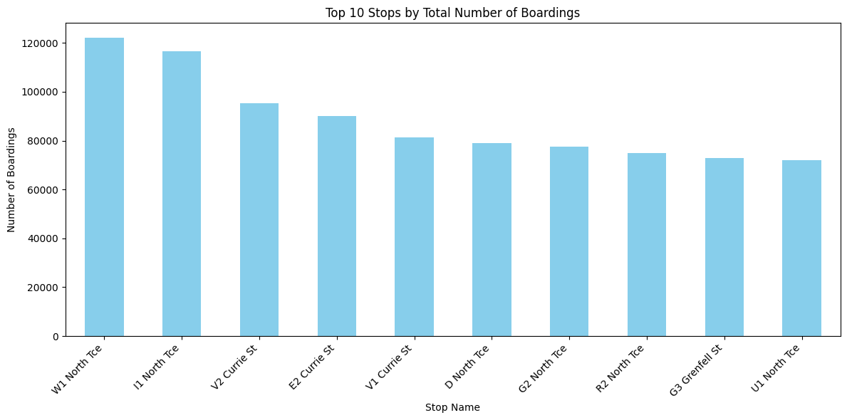
import pandas as pd
# Group by RouteID and sum the NumberOfBoardings
boarding_by_route = data.groupby('RouteID')['NumberOfBoardings'].sum()
# Display the result
print(boarding_by_route)
RouteID
117 312470
118 319790
140 83064
141 331118
142 79091
147 169540
148 5190
150 318672
168 296199
169 13397
170 143076
171 91911
100 328740
100B 8250
100C 11828
100K 6364
100N 6419
100P 13277
100S 260
101 39114
115 15460
117 67637
142 287270
144 183253
144G 15814
147 136496
150 105953
150B 55517
150P 8147
155 98191
157 307301
157X 81745
162 92171
167 237238
167C 32195
168 30858
Name: NumberOfBoardings, dtype: int64

# Group by StopID and calculate the average number of boardings
avg_boardings_per_stop = data.groupby('StopID')['NumberOfBoardings'].mean()
# Display the result
print(avg_boardings_per_stop)
StopID
10817 2.776013
10818 2.333333
10843 2.257143
10877 2.326316
10879 1.400000
...
18408 1.875000
18409 2.714286
18410 1.500000
18411 1.156250
18493 9.122678
Name: NumberOfBoardings, Length: 969, dtype: float64
# Convert WeekBeginning to datetime and extract week number
data['WeekBeginning'] = pd.to_datetime(data['WeekBeginning'])
data['WeekNumber'] = data['WeekBeginning'].dt.week
# Group by StopName and WeekNumber, then sum the NumberOfBoardings
weekly_boarding_counts = data.groupby(['StopName', 'WeekNumber'])['NumberOfBoardings'].sum()
# Find stops with the highest weekly boarding counts
stops_with_highest_boardings = weekly_boarding_counts.groupby('StopName').idxmax()
# Display the result
print(stops_with_highest_boardings)
StopName
1 Anzac Hwy (1 Anzac Hwy, 26)
1 Fullarton Rd (1 Fullarton Rd, 8)
1 George St (1 George St, 27)
1 Glen Osmond Rd (1 Glen Osmond Rd, 33)
1 Henley Beach Rd (1 Henley Beach Rd, 26)
...
Zone B Registry Rd Flinders Un (Zone B Registry Rd Flinders Un, 11)
Zone B West Lakes Interchange (Zone B West Lakes Interchange, 26)
Zone C Moseley St (Zone C Moseley St, 26)
Zone D Arndale Interchange (Zone D Arndale Interchange, 38)
Zone D Port Adelaide Interchan (Zone D Port Adelaide Interchan, 26)
Name: NumberOfBoardings, Length: 583, dtype: object
Analyzing Trends Over Time (Weekly/Monthly)
# Convert WeekBeginning to datetime and extract week and month
data['WeekBeginning'] = pd.to_datetime(data['WeekBeginning'])
data['WeekNumber'] = data['WeekBeginning'].dt.week
data['Month'] = data['WeekBeginning'].dt.month
# Group by WeekNumber and Month, then sum the NumberOfBoardings
weekly_boarding_trends = data.groupby(['WeekNumber', 'Month'])['NumberOfBoardings'].sum()
# Display the result
print(weekly_boarding_trends)
WeekNumber Month
1 1 59791
2 1 55026
3 1 67844
4 1 62204
5 2 87621
6 2 79964
7 2 86610
8 2 91046
9 3 98500
10 3 66953
11 3 94828
12 3 95643
13 3 94406
14 4 92959
15 4 62636
16 4 51434
17 4 88624
18 5 90852
19 5 92782
20 5 92112
21 5 89378
22 6 91608
23 6 73602
24 6 83086
25 6 76725
26 6 161049
27 7 121795
28 7 70588
29 7 85288
30 7 94344
31 8 95061
32 8 93992
33 8 92247
34 8 95341
35 9 94762
36 9 93643
37 9 94053
38 9 89866
39 9 67959
40 10 65428
41 10 87246
42 10 87703
43 10 86839
44 11 84346
45 11 82642
46 11 81556
47 11 80333
48 12 80176
49 12 75652
50 12 66079
51 12 37207
52 12 41587
Name: NumberOfBoardings, dtype: int64

